Text Area: | 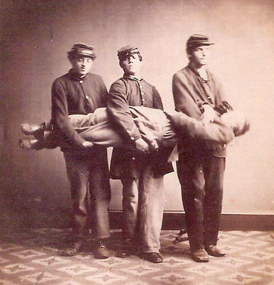  Ambulance Support Team Demonstrates  Carrying Procedure  Text Area:

